St. Sylvester 2023 - 2024

School Supply List
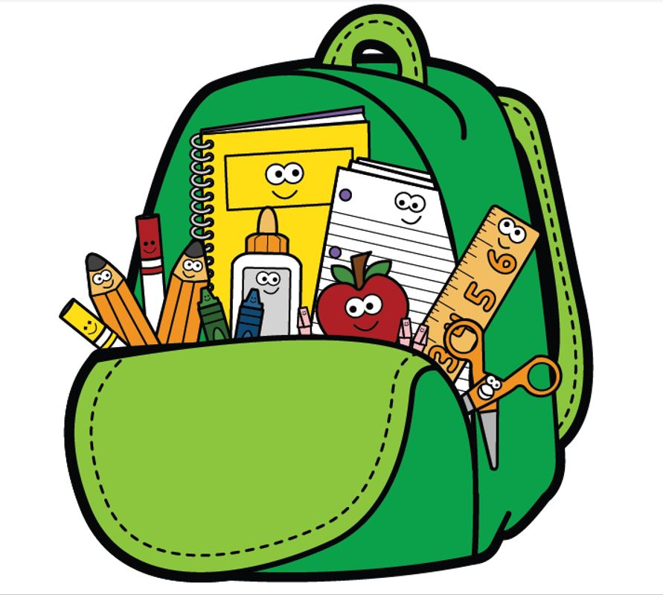
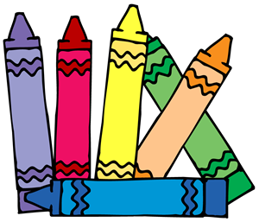
Pre-K -Ages 3 & 4
*Please write your child’s name on all personal items.  Small toy for the first day of school  1 Blanket for nap time with name  1 Pillow for nap time with name  1 Complete set of clothing & shoes  In labeled Ziploc bag  1 Family picture to hang in locker  1 Standard size book bag  (no wheels, large enough to fit folders)  1 Plastic folder w/pockets | 2 Boxes of 24 crayons  1 Pkg of Crayola watercolor paints  2 Boxes of Crayola washable markers  1 Box of Colored Pencils  6 Glue sticks  1 bottle of Elmer’s glue  1 bottles of hand soap  1 package of paper plates (Girls)  (non styrofoam)  1 package of paper bags (Boys)  2 Boxes of 5oz Dixie Cups | 4 Containers of baby wipes  1 8oz.-10oz Hand Sanitizer  2 Large boxes of Kleenex  8 Rolls of paper towels  2 Can of Lysol spray  1 Box of Band-Aids  6 Containers of Clorox disinfecting wipes  Ziploc Bags:  1 Box gallon size  1 Box quart size
Kindergarten

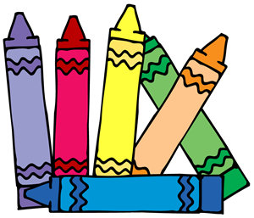

1 Complete set of clothing  In labeled Ziploc bag  1 Book bag (no wheels)  3 Plastic two pocket folders with name  4 Fat yellow pencils  2 Box of 24 pack Crayola crayons  2 Box of Fat Point washable markers  2 Package of 24 colored pencil | 1 Wide ruled spiral notebook with name  2- Pkgs. Expo Dry Erase markers  2 Chisel – Black Only  1 Box sandwich size Ziploc bags (Girls)  1 Box of snack size Ziploc bags  1 Box gallon size Ziploc bags (Boys)  1 Box quart size Ziploc bags (Girls  1 Hand sanitizer 8oz. (Boys) | 8 Rolls of paper towels  6 Clorox disinfecting wipes  2 Containers of Baby wipes  2 Large boxes of Kleenex  1 Pkg of Dixie Paper Cups  1 Wired headphones - Labeled  1 Box of band-aids
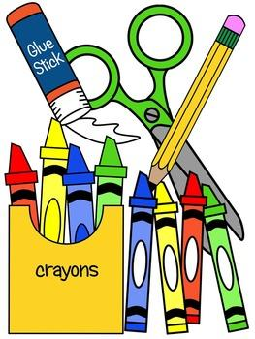
=
1st & 2nd Grade

Please label all of your child’s  Items with name and grade  1 Book bag (no wheels)  3 Spiral Wide notebooks (70 pages)  (red,blue,yellow)  3 Plastic two pocket folders  (red,blue,yellow)  36 #2 sharpened pencils  3 Pink erasers  1 Pack of staples  8 Glue sticks(1st Grade only)  1 Pkg fat point marker (non-scented) | 1 24 pack of colored pencils  1 Soft pencil case  1 Pencil sharpener  1 24 pack of crayons  1 Pair of blunt scissors  1 small white board  1 white board eraser  Tape (Package of 3)  Girls- Clear scotch tape  Boys-Masking tape  1 Homework assignment notebook  (purchased on Book Day) | 1 Pkg of construction paper (1st Gr.)  1 Pkg of Dry colored erase markers  1 Bottle of hand soap (1st Grade)  2 Rolls of paper towels  2 8oz. Bottle of hand sanitizer  2 Boxes of Kleenex  2 Containers of Clorox wipes  1 Container of baby wipes- (1st Grade Girls)  1 Lysol Spray- (boys)  1 Pkg of 3x3 sticky notes (2nd Grade)  1 12 inch ruler (2nd Gr.)  4 Large glue sticks (2nd Gr.)

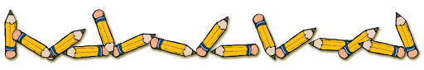
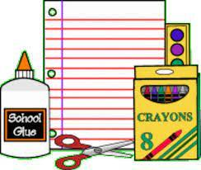
3rd Grade

Please label all of your child’s  Items with name and grade  1 Book bag (no wheels)  Spiral notebooks (Wide)  (red, blue, yellow, green, purple)  1 Composition notebook (science)  3 Plastic 2 pocket folders  (blue, red, yellow)  1 Pack of 24 colored pencils  1 Pack of 24 crayons  1 Hardcover pencil case  36 #2 Pencils sharpened  1 Pencil sharpener | 3 Pink erasers  1 Pkg of index cards  1 Pkg of 3x3 sticky notes  1 12 inch ruler  4 Large Glue sticks  1 Elmer’s glue bottle (Large)  1 Pair of blunt scissors  1 Pack of dry erase markers (colored)  1 Pkg fat point markers (non-scented)  3 Pkg of Clear Scotch Tape (Girls)  3 Pkg of Masking Tape (Boys) | 2 Clorox disinfecting wipes  1 Lysol spray  2 8oz. Bottle of hand sanitizer  3 Boxes of Kleenex  2 Rolls of paper towels  1 Box of baby wipes  1 Box of Ziploc Sandwich Size (Boys)  1 Box of Ziploc Gallon Size (Girls)  1 Homework assignment notebook  (purchased on Book Day)
4th & 5th Grade

1 Book Bag (no wheels)  2 Packs wide rule notebook paper  5 Wide rule spiral notebooks  (red, blue, green, purple, yellow)  3 Two-pocket folders  (red, blue, yellow)  1 Pkg washable markers (non-scented)  1 Pack of 24 crayons  1 Pack of colored pencils  1 Homework assignment notebook (purchased on Book Day) | 1 Pencil case  36 #2 Pencils  3 Pink erasers  1 12 inch ruler  1 Pencil sharpener (manual, not electric)  1 Pair Fiskar pointed scissors  4 Glue sticks  3 Elmer’s glue bottles (4th Gr. only)  3 Highlighters (different colors)  1 Pack of clear tape  1 Pkg of 3x3 sticky notes  1 Pack of Dry Erase markers (chisel not skinny) | 1 Package of 3x5 index cards  1 Ream white copy paper  1 Set of Wired headphones  3 Boxes of Kleenex  1 Container of baby wipes  1 Bottle of hand sanitizer 8oz.  4 Clorox disinfecting wipes  4 Rolls of paper towels  1 Bottle of Hand soap  1 Bottle of Lysol spray  1 Box of Ziploc Sandwich Size (Boys)  1 Box of Ziploc Gallon Size (Girls)
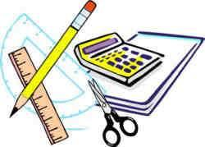
6th - 8th Grade

1 Book Bag (no wheels)  1 Pencil Case  24 #2 Pencils  2 Erasers (white)  12 Pens (black/blue)  1 Set of washable markers  1 Set of colored pencils or crayons  3 Highlighters (different colors)  1 Pack of chisel tip dry erase markers  1 Pair of pointed Fiskar scissors  2 Pkg of 3x3 sticky notes | 1 Pack of Clear tape  1 Package 3x5 index cards  2 Packs of glue sticks  1 Ream of printer paper  1 Packages of loose-leaf paper (wide ruled)  1 calculator (non scientific)  1 compass (8th grade only)  1 protractor (8th grade only)  1 set of Wired headphones  1 Homework assignment notebook  (purchased on Book day) | 5 Plastic folders  (green, red, blue, purple, +1 any color)  2 3-Subject spiral notebooks  1 -blue 1-any color  4 1-Subject spiral notebooks  1-purple 1-green 1-red 1-student choice  1 Pump hand sanitizer  1 Bottle of Hand soap  2 Boxes of Kleenex  4 Rolls of paper towels  4 Clorox disinfecting wipes

